**ONLINE REATAIL DATABASE MANAGEMENT SYSTEM**

1. **How to create database?**

Create database online_retail_db

1. **How to create table?**
2. **Customer_details**

create table customer_details

(

Customer_id int(10) primary key,

Customer_name varchar(100),

Phone_num int(20),

State varchar(90),

Address varchar(200)

);

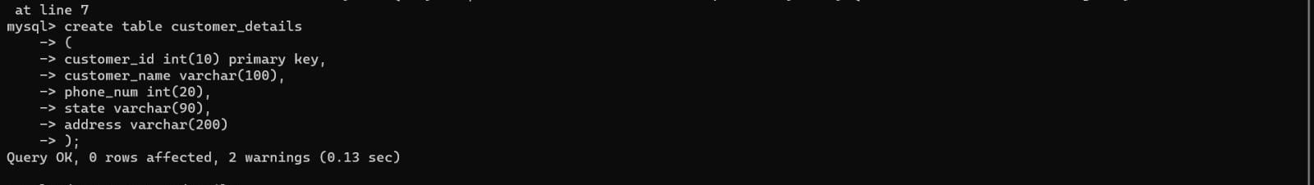

1. **Order_details**

create table order_details

(

order_id int(100) primary key,

customer_id int(10),

foreign key(customer_id) references customer_details(customer_id),

product_name varchar(90),

shipping_address varchar(100),

quantity int(100),

status varchar(90)

);

1. **Payment_details**

create table payment_details

(

pay_id int(100),

customer_name varchar(90),

m_o_p varchar(90),

status varchar(90)

);

1. **Delivery_details**

create table delivery_details

(

order_id int(10),

foreign key (order_id) references order_details(order_id),

customer_name varchar(100),

phone_num int(20),

tracking_num int (30),

status varchar(100)

);

1. **Show description of table?**
2. desc customer_details;

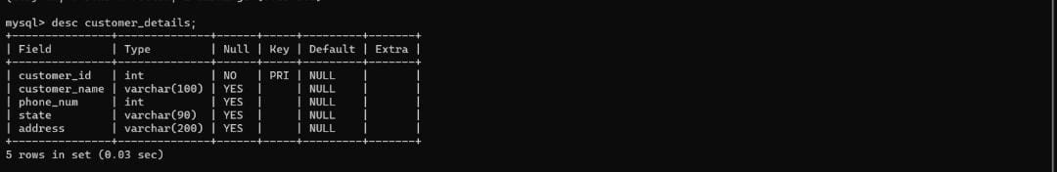

1. desc order_details;
2. desc payment_details;
3. desc delivery_details;
4. **How to insert values in tables?**

insert into customer_details( customer_id , customer_name , phone_num , state , address)

values

(101, 1, "Airmax 90", "Shivaji nagar", 1, "packed"),

(102, 2, "Air Jordan4" , "South Mumbai", 2, "in process"),

(103,3, "Yeezy 700v3" , "ulwe", 1, "packed"),

(104, 4 , "Nike Blazer" , "alibaug" ,3, "packed"),

(105, 5, "Adidas Forum Low", "bhopal" , 1, "packed"),

(106, 5, "Nike SB Dunk", "bhopal", 1, "packed"),

(107, 6, "Converse Chuck", "kochi", 1, "in process"),

(108, 4, "Air Jordan 1", "alibaug", 1, "in process"),

(109, 1, "Air Jordan 3 Palomino", "Shivaji Nagar", 1 ,"packed")

(110, 7, "Airforce 1 ", "bengal" ,1, "packed");

**Add column customer_id after pay_id?**

mysql> alter table payment_Details add customer_id int(10) after pay_id;

Query OK, 0 rows affected, 1 warning (0.03 sec)

Records: 0 Duplicates: 0 Warnings: 1

mysql> update payment_details set customer_id= 1 where pay_id=40064259;

Query OK, 1 row affected (0.03 sec)

Rows matched: 1 Changed: 1 Warnings: 0

mysql> update payment_details set customer_id= 2 where pay_id=40064260;

Query OK, 1 row affected (0.02 sec)

Rows matched: 1 Changed: 1 Warnings: 0

mysql> insert into payment_details (pay_id,customer_id,customer_name,m_o_p,status)

-> values

-> (40064261, 3, "Arsh","Phonepe", "pending"),

-> (40064262 , 4, "Maithili", "Gpay", "paid"),

-> (40064263, 5, "Saqib" , "Phonepe", "pending");

Query OK, 3 rows affected (0.12 sec)

Records: 3 Duplicates: 0 Warnings: 0

mysql> insert into payment_details(pay_id, customer_id, customer_name, m_o_p, status)

-> values

-> (40064264, 6, "Aman","Credit card", "paid"),

-> (40064265, 7, "Zainab", "Paytm", "paid"),

-> (40064266, 5, "saqib", "Phonepe", "paid"),

-> (40064267, 1, "sheefa", "Gpay", "paid");

Query OK, 4 rows affected (0.03 sec)

Records: 4 Duplicates: 0 Warnings: 0

DELIVERY_DETAILS

mysql> insert into delivery_details(order_id,customer_name,phone_num,tracking_num,status)

-> values

-> (103, "Arsh",9321616520, "TA316692070IN", "Delivered"),

-> (104, "Maithili", 9137875330, "TA316692071IN", "Shipped");

Query OK, 2 rows affected (0.03 sec)

Records: 2 Duplicates: 0 Warnings: 0

mysql> insert into delivery_details(order_id,customer_name,phone_num,tracking_num,status)

-> values

-> (105, "Saqib", 9372600515, "TA316692072IN", "Delivered"),

-> (106, "Aman", 8104870230, "TA316692073IN", "Shipped"),

-> (109, "sheefa", 9326085663, "TA316692073IN", "In Transit"),

-> (110, "Zainab", 8104131368, "TA316692074IN", "Shipped");

Query OK, 4 rows affected (0.33 sec)

Records: 4 Duplicates: 0 Warnings: 0

mysql> select*from delivery_details;

+----------+---------------+------------+---------------+------------+

| order_id | customer_name | phone_num | tracking_num | status |

+----------+---------------+------------+---------------+------------+

| 101 | sheefa | 9326085663 | TA316692069IN | In Transit |

| 103 | Arsh | 9321616520 | TA316692070IN | Delivered |

| 104 | Maithili | 9137875330 | TA316692071IN | Shipped |

| 105 | Saqib | 9372600515 | TA316692072IN | Delivered |

| 106 | Aman | 8104870230 | TA316692073IN | Shipped |

| 109 | sheefa | 9326085663 | TA316692073IN | In Transit |

| 110 | Zainab | 8104131368 | TA316692074IN | Shipped |

+----------+---------------+------------+---------------+------------+

7 rows in set (0.00 sec)